# Entering name

Expected input: upper and lower case, ‘-‘, ‘/’

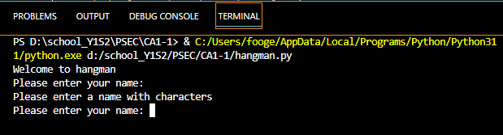

Figure . Entering blank input

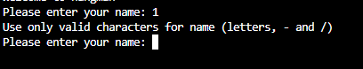

Figure . Entering invalid character (e.g numbers)

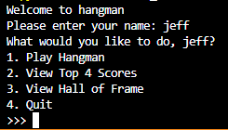

Figure . Entering valid name (letters)

# Menu

Expected input: number between 1 and 4

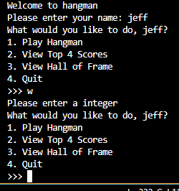

Figure . Entering a letter

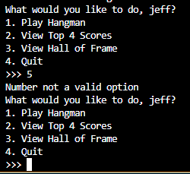

Figure . Entering a number that is not a valid option

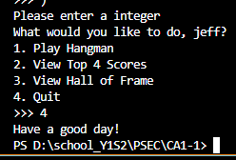

Figure . Entering a valid number

Figure . Entering a decimal point number

## 2.2 Hangman rules

Expected input: ‘y’ to play game, anything else cancels

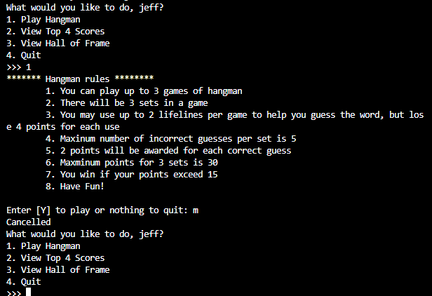

Figure ..1 Entering letter other than 'y'

Figure .5.2 Entering a number

Figure .5.3 If 'y' is entered

# Hangman game

Expected input: letter (that have not been tried), ” ‘ “, 0 (for lifeline)

Figure . Input number (that is not 0)

Figure . Input special character

Figure . Input incorrect letter

Figure . Input correct letter

Figure . Input letter that have been tried

Figure . Input blank spaces

Figure . Input '0'

Figure . Making 5 incorrect guesses

Figure . Guessing all letters

## ‘Continue’ prompt between sets

Expected input: ‘y’ to continue or ‘n’ to quit playing

Figure ..1 Entering another letter

Figure 3.10.2 Entering blank space



Figure .10.3 Entering 'n'

Figure .10.4 Entering 'y'

## 3.2 Lifelines

Expected input: 1 or 2, unless corresponding hint has already been used for that word

Figure .11.2 Entering letter

Figure .11.2 Entering either of the number

Figure .11.3 Entering the number of a hint that is already used

## End of game display and prompt

Expected input: ‘y’ to play next game, ‘n’ to stop

Figure .12.1 Scoring below winning score



Figure .12.2 Scoring above the winning score

Figure .12.3 Scoring the max score without the use of lifelines

Figure .12.4 Entering other letters or numbers

Figure .12.5 input 'y'

Figure .12.6 Input 'N'

Figure .12.7 When a game finishes and player have no more attempts (“Out of attempts for hangman” is updated menu)

# Other script functions

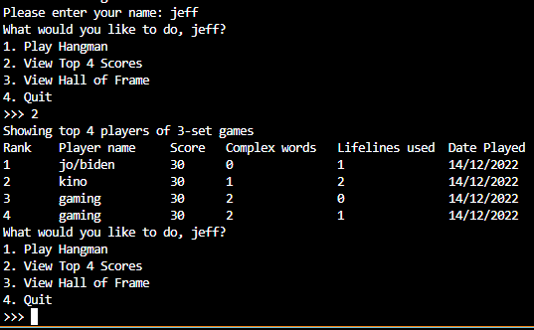

Figure . Selecting '2' in menu (Top X players)

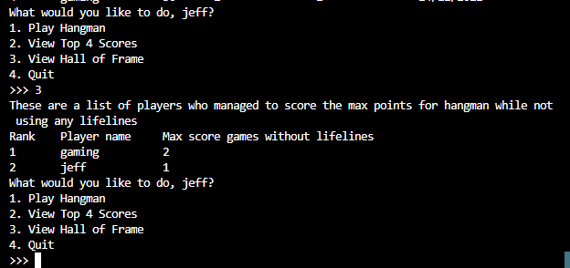

Figure . Selecting '3' in menu (Players in hall of fame)

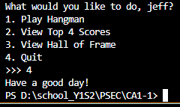

Figure . Selecting '4' (quit game)